**Exercise No:5**

**Date:15/10/2020**

**Aim**.**:**  Write a Python function to print missing characters to make string pangram.

**Program:**

**x=input()**

**x=set(x.strip())**

**x.remove(chr(32))**

**y="abcdefghijklmnopqrstuvwxyz"**

**y=set(y)**

**y=y.difference(x)**

**y=list(y)**

**y.sort()**

**print("".join(y))**

**Link:**

[**http://103.53.53.18/mod/vpl/forms/edit.php?id=235&userid=1782**](http://103.53.53.18/mod/vpl/forms/edit.php?id=235&userid=1782)

**Output:**

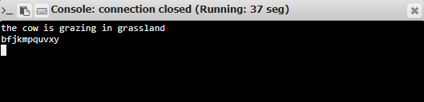

**Result:**

The program was executed successfully and the output was verified.